QUESTION : 1
Create two tables: Influencers (id, name) and Collaborations (id, influencer1_id, influencer2_id, collab_date). Write a SQL FULL JOIN query to list all influencers and show their collaboration partner names if any, including influencers with no collaborations :
TABLE Influencers:
CREATE TABLE Influencers(
id INT,
name VARCHAR(100),
PRIMARY KEY(id)
);

INSERT INTO Influencers VALUES (1,'Rahul'), (2,'Priya'), (3,'Amit'),
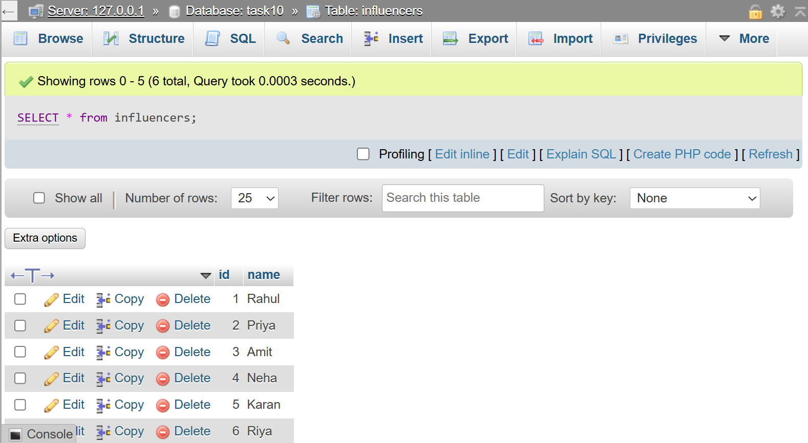
(4,'Neha'), (5,'Karan'), (6,'Riya');

TABLE Collaborations:
CREATE TABLE Collaborations(
id INT,
influencer1_id INT,
influencer2_id INT,
collab_date DATE,
PRIMARY KEY(id),
FOREIGN KEY(influencer1_id) REFERENCES Influencers(id),
FOREIGN KEY(influencer2_id) REFERENCES Influencers(id)
);
INSERT INTO Collaborations VALUES
(101,1,2,'2026-01-15'),
(102,2,3,'2026-02-20'),
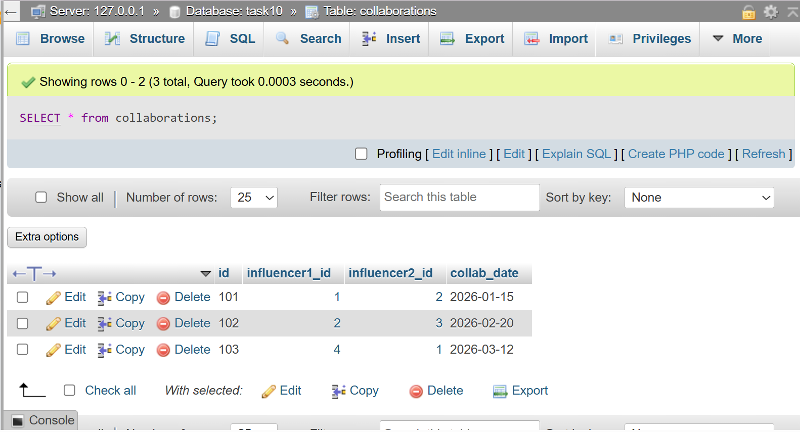
(103,4,1,'2026-03-12');

SELECT i.name AS Influencer,p.name AS Collaboration_Partner,c.collab_date
FROM Influencers i LEFT JOIN Collaborations c
ON i.id=c.influencer1_id LEFT JOIN Influencers p ON c.influencer2_id=p.id
UNION
SELECT i.name AS Influencer,p.name AS Collaboration_Partner,c.collab_date
FROM Influencers i RIGHT JOIN Collaborations c
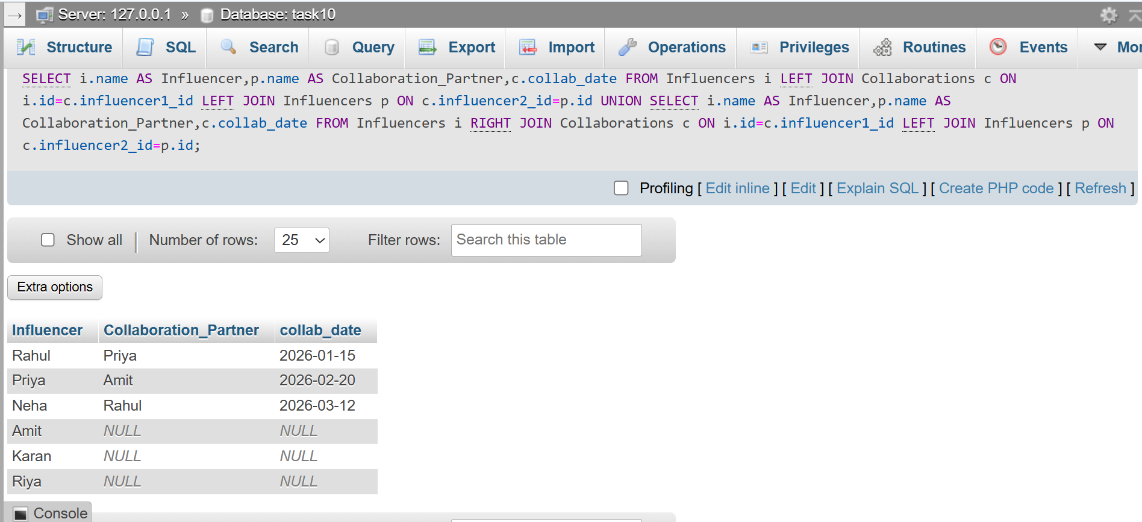
ON i.id=c.influencer1_id LEFT JOIN Influencers p ON c.influencer2_id=p.id ;
QUESTION : 2
Using a SELF JOIN, write a query on a table called Playlists (id, user_id, playlist_name, parent_playlist_id) to display each playlist alongside its parent playlist name, similar to how Spotify shows nested playlists.<br><br><em><strong>Hint:</strong> Join Playlists with itself on parent_playlist_id = id.</em> :
TABLE Playlists :
CREATE TABLE Playlists(
id INT,
user_id INT,
playlist_name VARCHAR(100),
parent_playlist_id INT,
PRIMARY KEY(id)
);
INSERT INTO Playlists(id,user_id,playlist_name,parent_playlist_id)
VALUES
(1,101,'Music',NULL),
(2,101,'Workout',1),
(3,101,'Gym Songs',2),
(4,102,'Travel',NULL),
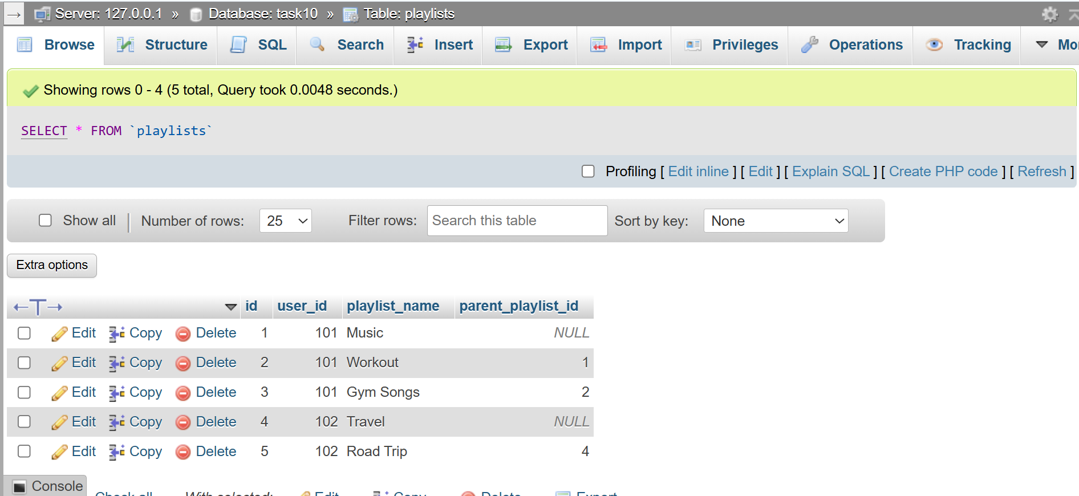
(5,102,'Road Trip',4) ;
SELECT c.playlist_name AS Playlist,p.playlist_name AS Parent_Playlist
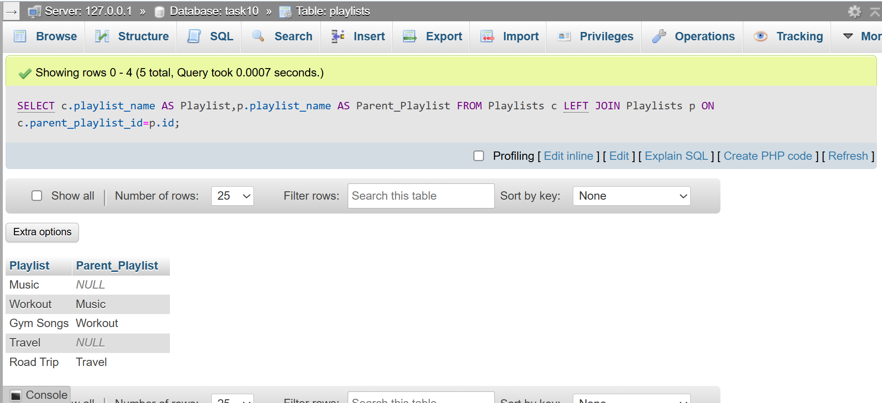
FROM Playlists c LEFT JOIN Playlists p ON c.parent_playlist_id=p.id ;
QUESTION : 3
Given three tables: Users (id, username), Orders (id, user_id, order_date), and Payments (id, order_id, amount), write a SQL query using multiple JOINs to display each username, their order date, and payment amount, showing all users even if they have no orders or payments:

TABLE Users :
CREATE TABLE Users(
id INT PRIMARY KEY,
username VARCHAR(100)
);

INSERT INTO Users(id,username)
VALUES (1,'Rahul'), (2,'Priya'), (3,'Amit'), (4,'Neha') ;

TABLE Orders :
CREATE TABLE Orders(
id INT PRIMARY KEY,
user_id INT,
order_date DATE
) ;

INSERT INTO Orders(id,user_id,order_date)
VALUES (101,1,'2026-07-01'), (102,2,'2026-07-02'), (103,1,'2026-07-05') ;

TABLE Payments :
CREATE TABLE Payments(
id INT PRIMARY KEY,
order_id INT,
amount DECIMAL(10,2)
) ;

INSERT INTO Payments(id,order_id,amount)
VALUES
(1,101,450),
(2,102,700) ;

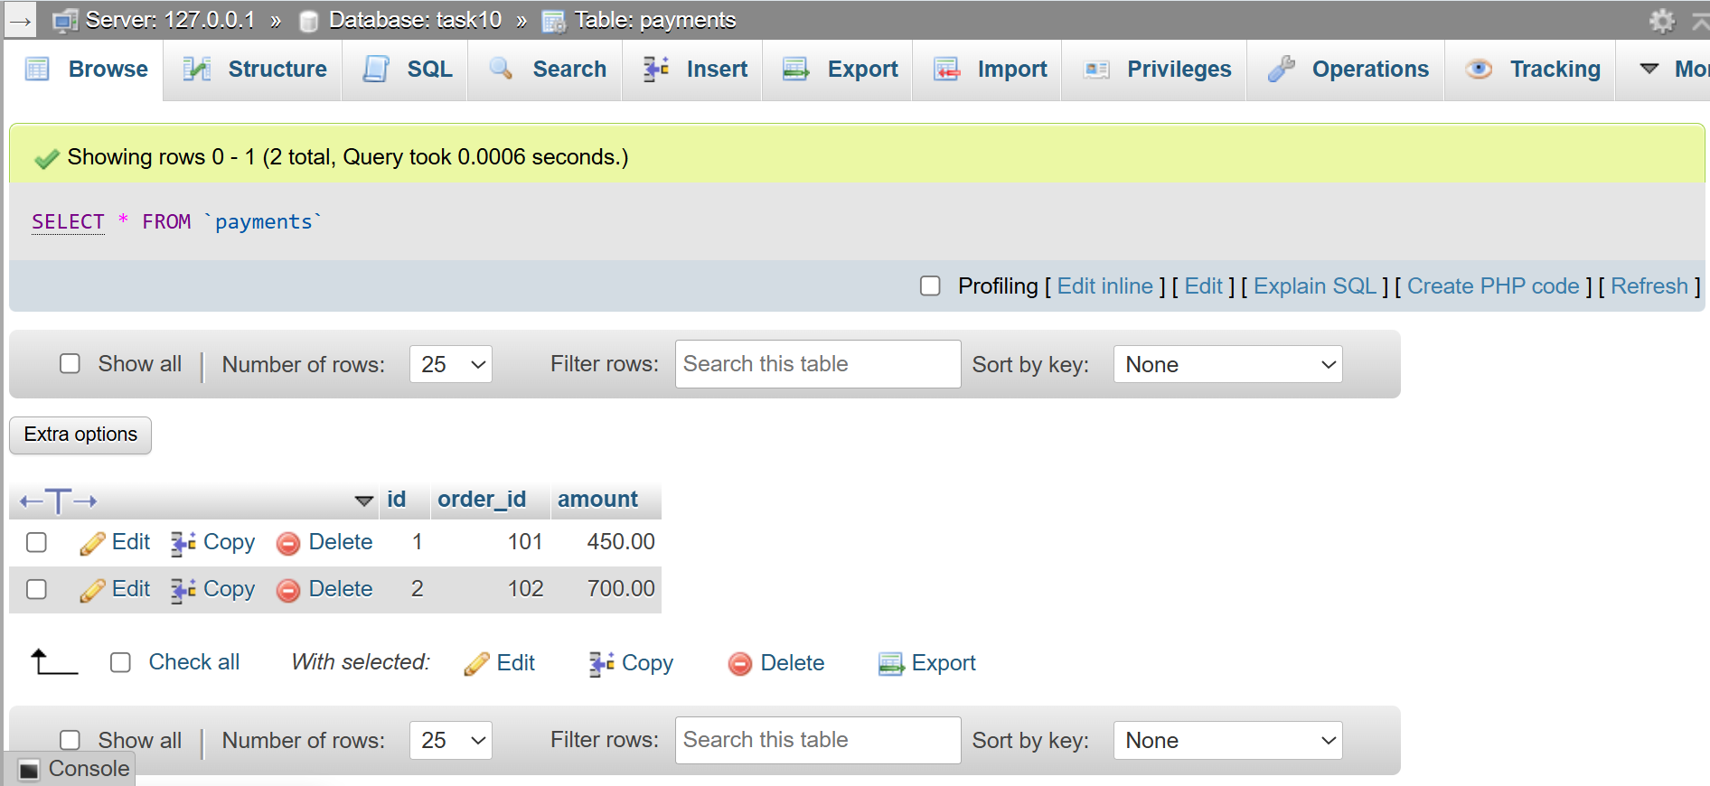
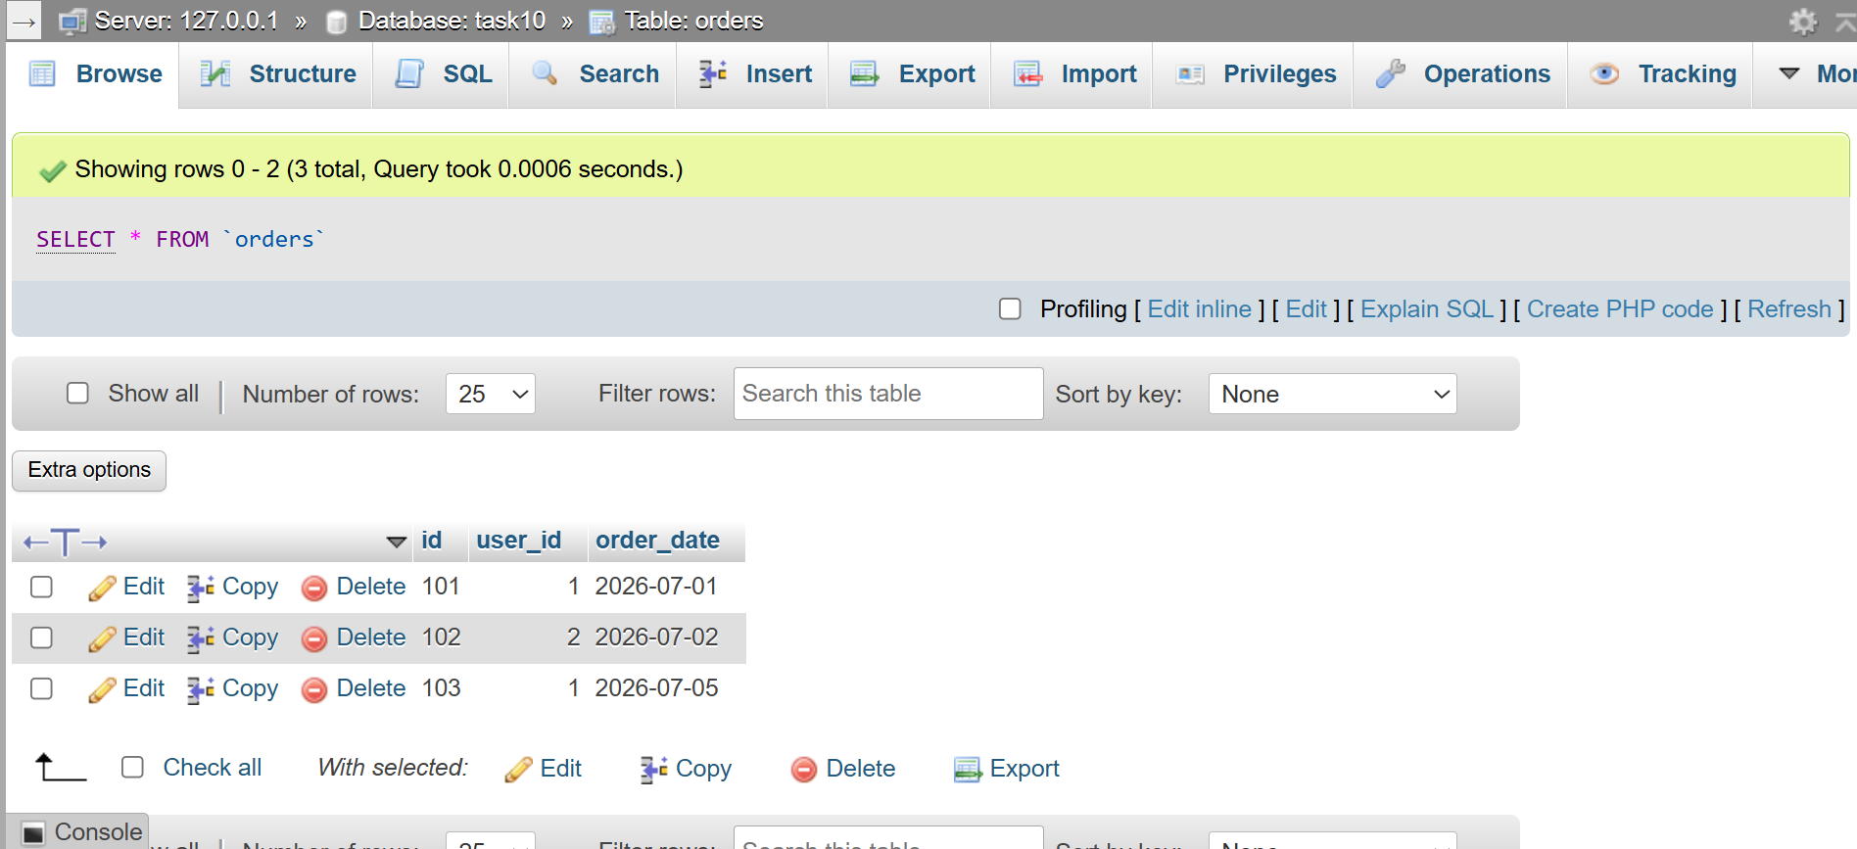
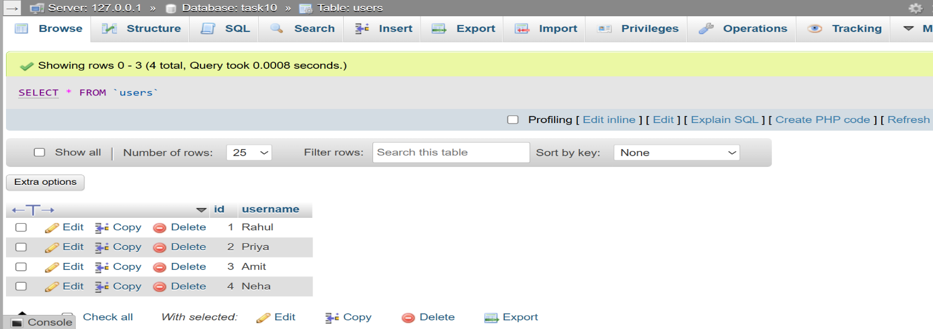
SELECT u.username,o.order_date,p.amount FROM Users as u
LEFT JOIN Orders as o ON u.id=o.user_id
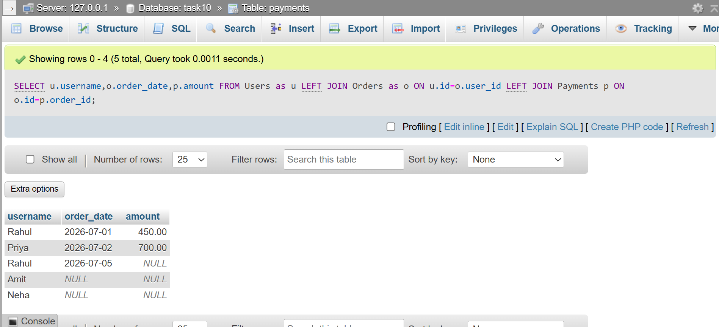
LEFT JOIN Payments p ON o.id=p.order_id ;
QUESTION : 4
You notice that your JOIN query between Zomato's Restaurants and Reviews tables is returning duplicate rows for some restaurants. Modify your query to eliminate duplicates and explain in one line why the duplicates were happening.<br><br><em><strong>Hint:</strong> Use DISTINCT or GROUP BY and consider the relationship between restaurants and reviews.</em> :

TABLE Restaurants :
CREATE TABLE Restaurants(
id INT PRIMARY KEY,
restaurant_name VARCHAR(100)
);
INSERT INTO Restaurants(id,restaurant_name)
VALUES (1,'Dominos'), (2,'Pizza Hut'), (3,'La Pinoz');

TABLE Reviews :
CREATE TABLE Reviews(
id INT PRIMARY KEY,
restaurant_id INT,
rating DECIMAL(2,1)
);

INSERT INTO Reviews(id,restaurant_id,rating)
VALUES (1,1,4.5),(2,1,5.0),(3,2,4.2),(4,2,4.8);
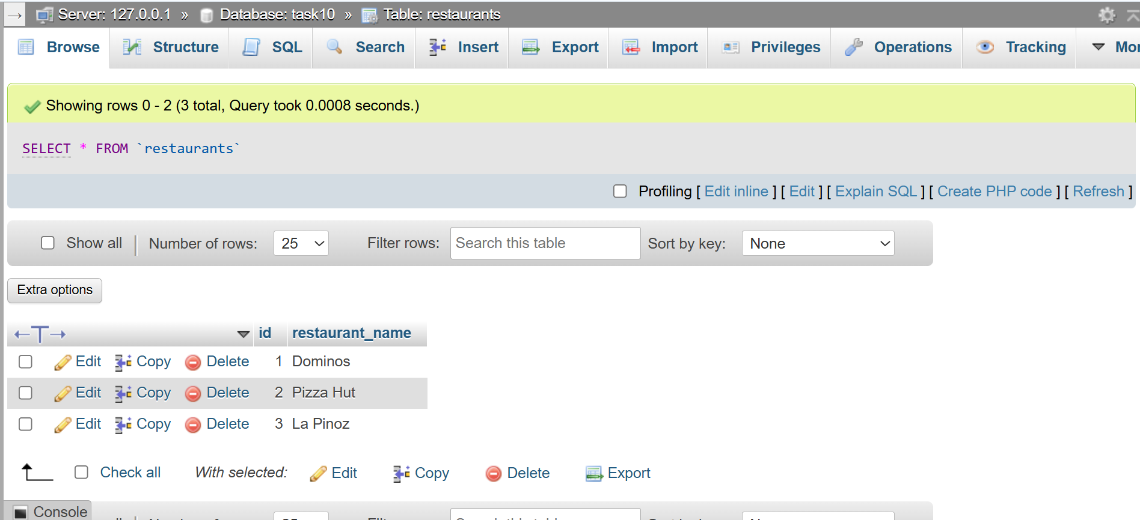
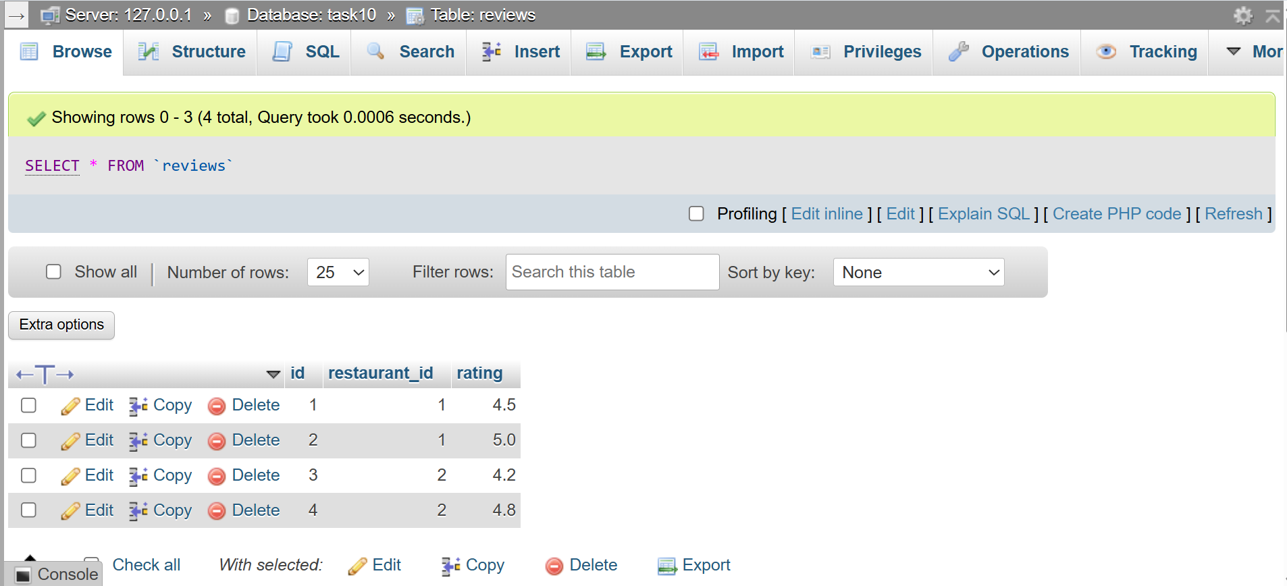
SELECT DISTINCT restaurants.restaurant_name
FROM Restaurants JOIN Reviews
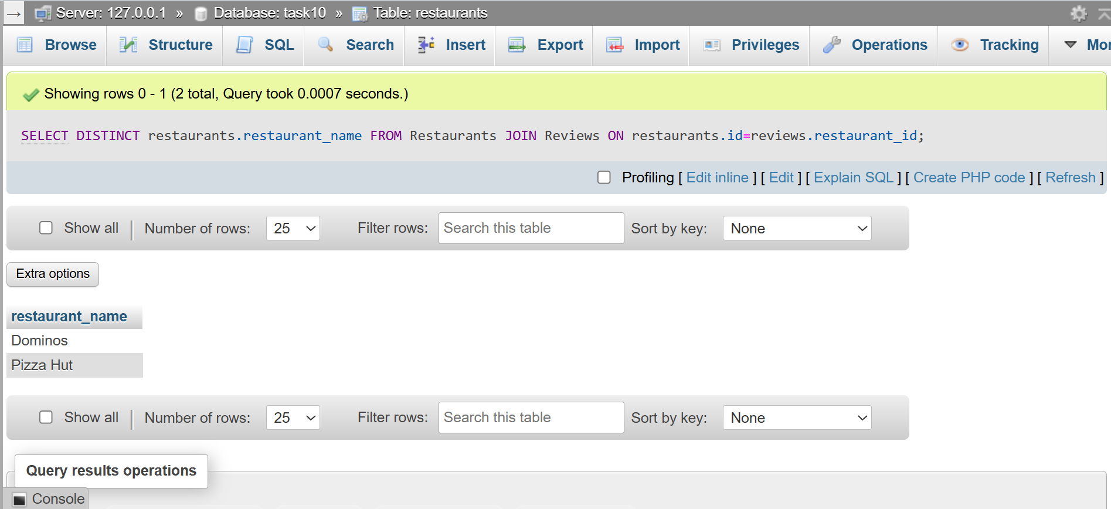
ON restaurants.id=reviews.restaurant_id;
Duplicates occurred because one restaurant can have multiple reviews, so the JOIN returned multiple matching rows…..

QUESTION : 5
Write two different JOIN queries on a Products and Categories table (like Flipkart) to list all products with their category names, but use different join conditions in each. Briefly explain which join condition is more efficient and why :

TABLE Categories :
CREATE TABLE Categories(
id INT PRIMARY KEY,
category_name VARCHAR(100)
) ;

INSERT INTO Categories(id,category_name)
VALUES (1,'Mobiles'),(2,'Laptops'),(3,'Fashion');

TABLE Products :
CREATE TABLE Products(
id INT PRIMARY KEY,
product_name VARCHAR(100),
category_id INT
);

INSERT INTO Products(id,product_name,category_id)
VALUES (101,'iPhone 15',1),(102,'Samsung S25',1),
(103,'Dell',2),(104,'Nike Shoes',3);
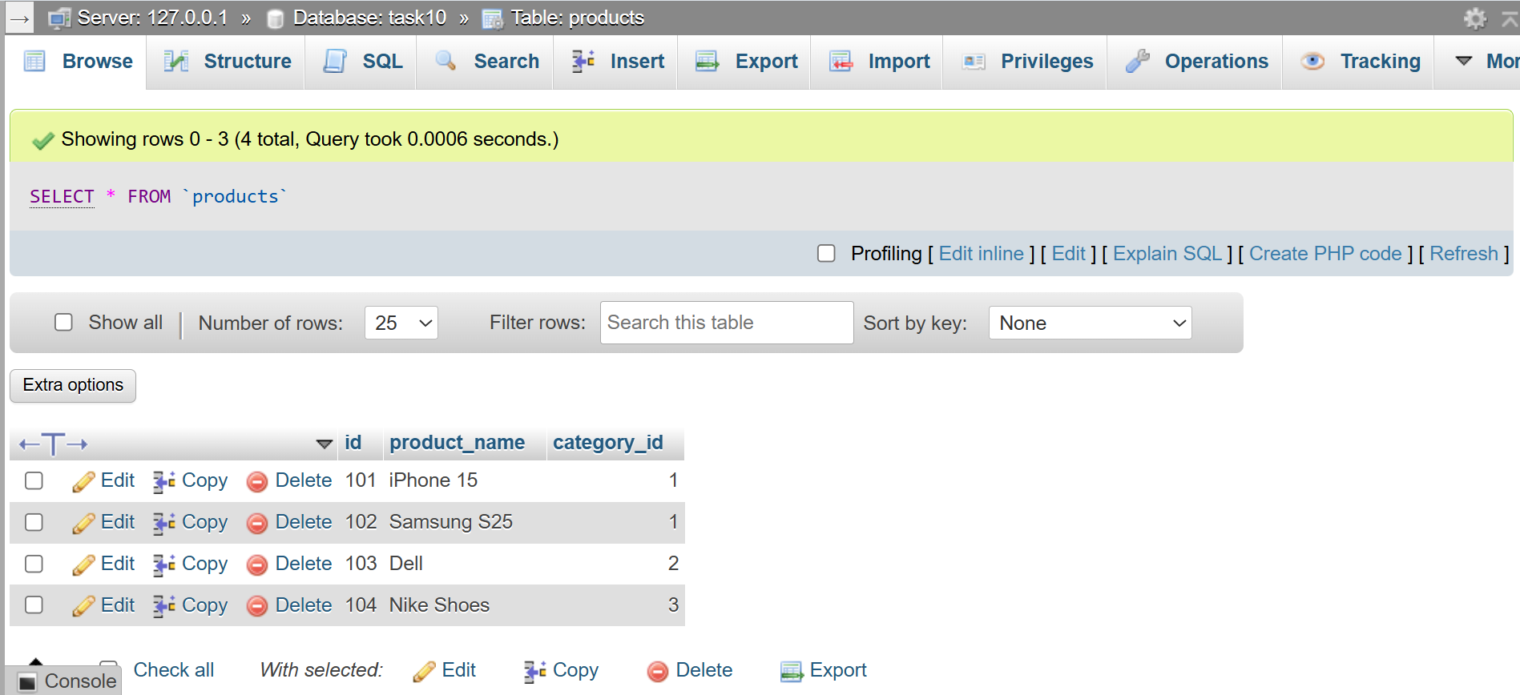
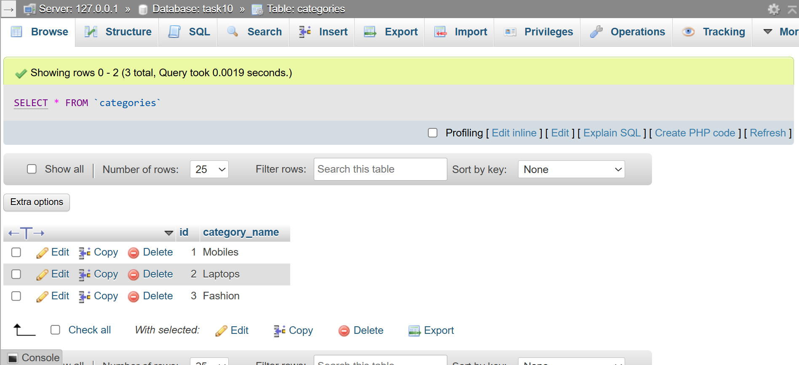
Using ON :
SELECT p.product_name,c.category_name
FROM Products as p INNER JOIN Categories as c ON p.category_id=c.id;

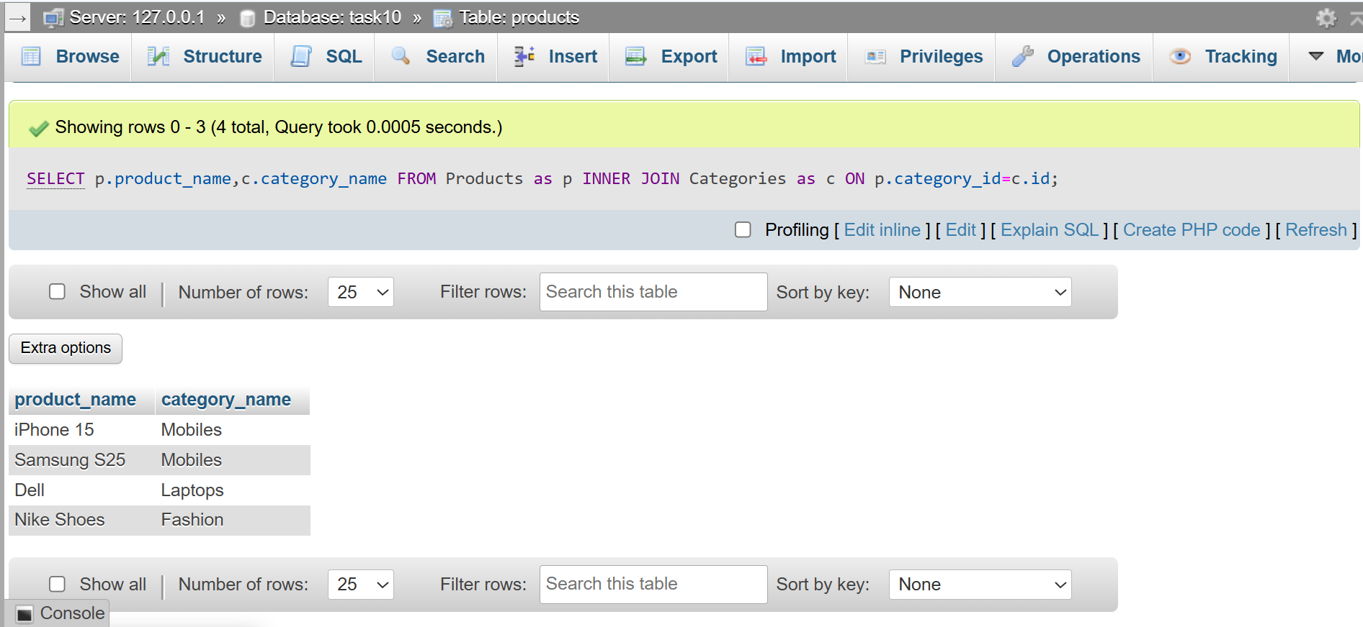
Using WHERE :
SELECT p.product_name,c.category_name
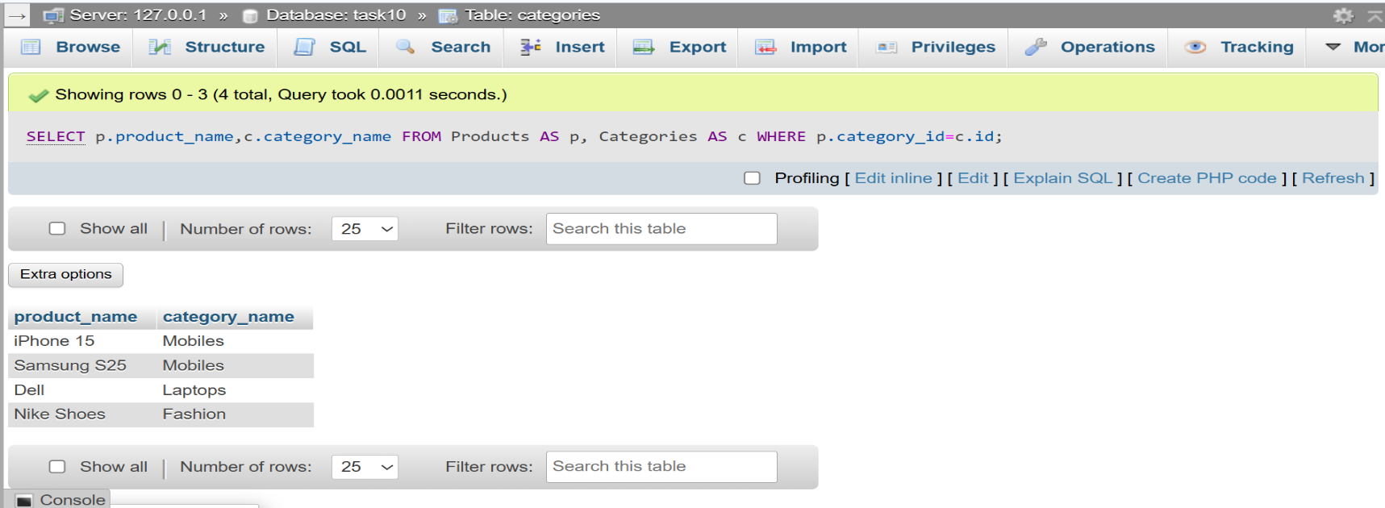
FROM Products AS p, Categories AS c WHERE p.category_id=c.id;
The INNER JOIN ... ON query is more efficient because it clearly defines the join condition, making the query easier to read and optimize…..

